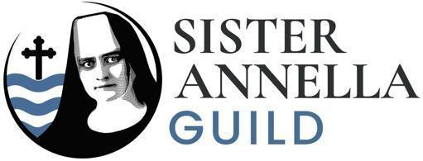  Bulletin Blurb
_______________________________________________________________
Sister Annella Zervas, OSB: the First Candidate for Sainthood from Minnesota and the Diocese of Crookston!
Bishop Andrew Cozzens and the Sister Annella Guild invite you to the opening Mass for the Cause of Canonization of Sister Annella—celebrated in person and via livestream—on Thursday, October 9, 2025, at 6:30 PM CDT at the Cathedral of the Immaculate Conception in Crookston, Minnesota. The doors will open at 4:00 PM, and Patrick Norton will share his story at 5:00 PM, right before the organ recital and Mass.
Gather with parish representatives, the Benedictine community, and the Zervas family for this historic occasion.
Learn more and support her cause by joining the Sister Annella Guild at sisterannella.org.

